**Optimization of an RBM Network for Change Detection in SAR images**

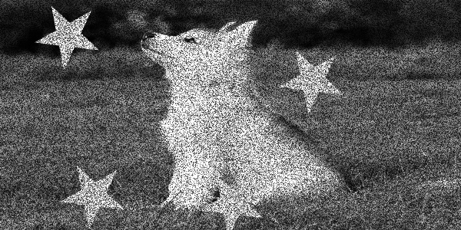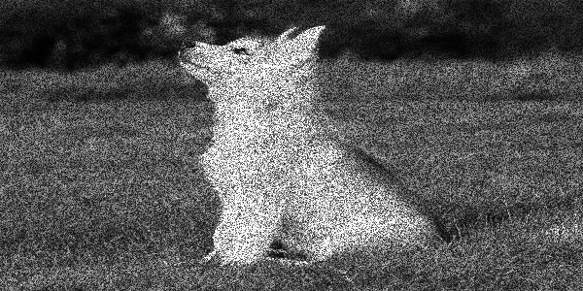**Puppy**



The biggest factor in the accuracy of a network seems to be the distribution and size of the pixels being tested. Thus, for every network, I tested many different sizes of labels.

**Networks Tested:**

**COMPARING FILTERED LABELS:**

**ORIGINAL NETWORK:**

Training Set: 10 sets of images, 180,000 pixels

Network Structure: [50 250 200 100 1], 100 batch size, 50 iterations

**ORIGINAL NETWORK WITH FILTERED TRAINING SET:**

Training Set: 30 sets of images, filtered to 50% changed, 90,000 pixels

Network Structure: [50 250 200 100 1], 100 batch size, 50 iterations

**ORIGINAL NETWORK WITH FILTERED TRAINING SET:**

Training Set: 30 sets of images, filtered to 25% changed, 180,000 pixels

Network Structure: [50 250 200 100 1], 100 batch size, 50 iterations

**ORIGINAL NETWORK WITH FILTERED TRAINING SET:**

Training Set: 30 sets of images, filtered to 10% changed, 180,000 pixels

Network Structure: [50 250 200 100 1], 100 batch size, 50 iterations

**ORIGINAL NETWORK WITH FILTERED TRAINING SET:**

Training Set: 30 sets of images, filtered to 9% changed, 180,000 pixels

Network Structure: [50 250 200 100 1], 100 batch size, 50 iterations

**ORIGINAL NETWORK WITH FILTERED TRAINING SET:**

Training Set: 30 sets of images, filtered to 5% changed, 180,000 pixels

Network Structure: [50 250 200 100 1], 100 batch size, 50 iterations

**COMPARING TRAINING SET SIZES:**

**ORIGINAL NETWORK:**

Training Set: 10 sets of images, 180,000 pixels

Network Structure: [50 250 200 100 1], 100 batch size, 50 iterations

**ORIGINAL NETWORK WITH LARGE TRAINING SET:**

Training Set: 30 sets of images, 700,000 pixels

Network Structure: [50 250 200 100 1], 100 batch size, 50 iterations

**COMPARING DIFFERENT LAYERS:**

**ORIGINAL NETWORK:**

Training Set: 10 sets of images, 180,000 pixels

Network Structure: [50 250 200 100 1], 100 batch size, 50 iterations

**3 LAYER NETWORK:**

Training Set: 10 sets of images, 180,000 pixels

Network Structure: [50 250 1], 100 batch size, 50 iterations

**COMPARING DIFFERENT ITERATIONS:**

**ORIGINAL NETWORK:**

Training Set: 10 sets of images, 180,000 pixels

Network Structure: [50 250 200 100 1], 100 batch size, 50 iterations

**FEWER ITERATIONS NETWORK:**

Training Set: 10 sets of images, 180,000 pixels

Network Structure: [50 250 200 100 1], 100 batch size, 25 iterations

**LARGER ITERATIONS NETWORK:**

Training Set: 10 sets of images, 180,000 pixels

Network Structure: [50 250 200 100 1], 100 batch size, 100 iterations

**COMPARING BATCH SIZE:**

**ORIGINAL NETWORK:**

Training Set: 10 sets of images, 180,000 pixels

Network Structure: [50 250 200 100 1], 100 batch size, 50 iterations

**LARGE BATCH NETWORK:**

Training Set: 10 sets of images, 180,000 pixels

Network Structure: [50 250 200 100 1], 1000 batch size, 50 iterations

**COMPARING NETWORK TYPE:**

**ORIGINAL BERNOULLI-BERNOULLI NETWORK:**

Training Set: 10 sets of images, 180,000 pixels

Network Structure: [50 250 200 100 1], 100 batch size, 50 iterations

**ORIGINAL GAUSSIAN-BERNOULLI NETWORK:**

Training Set: 10 sets of images, 180,000 pixels

Network Structure: [50 250 200 100 1], 100 batch size, 50 iterations